 

A Minor Project Report

On

## Smart Agriculture System

Under the guidance of

**Mr.** K. JEYAGANESH KUMAR

Assistant Professor/AI

**Submitted by**

AADHIGOWTHAM V S (927621BAD001)

AKHIL S T (927621BAD004)

KAVIN M (927621BAD022)

SAYNANE R M (927621BAD046)

### DEPARTMENT OF ARTIFICIAL INTELLIGENCE & DATASCIENCE

M.KUMARASAMY COLLEGE OF ENGINEERING

(Autonomous) KARUR – 639113

MAY -2023

VISION AND MISSION OF THE INSTITUTE:

### Vision:

To emerge as a leader among the top institutions in the field of technical education.

### Mission:

* Produce smart technocrats with empirical knowledge who can surmount the global challenges.
* Create a diverse, fully-engaged, learner-centric campus environment to provide quality education to the students.
* Maintain mutually beneficial partnerships with our alumni, industry and professional associations.

VISION AND MISSION OF THE DEPARTMENT:

### VISION

To reach excellent standards of quality-education by using latest tools and to be the

center of excellence by promoting knowledge centric education, innovation and state-of-

art research in the field of Artificial Intelligence and Data Science.

### MISSION

* M1: To impart quality and value based education and contribute towards innovation of computing, expert system, Data Science to raise satisfaction level of all stakeholders.
* M2: To educate the future Computing engineers with strong fundamentals by improving the teaching learning methodologies using contemporary aids.
* M3: Enabling students to get expertise in critical skills with Artificial Intelligence domain and facilitate socially responsive research and innovation.
* M4: To encourage professional development of students that will inculcate ethical values and leadership skills while working with the community to address societal .

### PROGRAMME OUTCOMES (POs)

* **Engineering knowledge:** Apply the knowledge of mathematics, science, engineering fundamentals, and an engineering specialization to the solution of complex engineering problems.
* **Problem analysis:** Identify, formulate, review research literature, and analyze complex engineering problems reaching substantiated conclusions using first principles of mathematics, natural sciences, and engineering sciences.
* **Design/development of solutions:** Design solutions for complex engineering problems and design system components or processes that meet the specified needs with appropriate consideration for the public health and safety, and the cultural, societal, and environmental considerations.
* **Conduct investigations of complex problems:** Use research-based knowledge and research methods including design of experiments, analysis and interpretation of data, and synthesis of the information to provide valid conclusions.
* **Modern tool usage:** Create, select, and apply appropriate techniques, resources, and modern engineering and IT tools including prediction and modeling to complex engineering activities with an understanding of the limitations.
* **The engineer and society:** Apply reasoning informed by the contextual knowledge to assess societal, health, safety, legal and cultural issues and the consequent responsibilities relevant to the professional engineering practice.
* **Environment and sustainability:** Understand the impact of the professional engineering solutions in societal and environmental contexts, and demonstrate the knowledge of, and need for sustainable development.
* **Ethics:** Apply ethical principles and commit to professional ethics and responsibilities and norms of the engineering practice.
* **Individual and team work:** Function effectively as an individual, and as a member or leader in diverse teams, and in multidisciplinary settings.
* **Communication:** Communicate effectively on complex engineering activities with the engineering community and with society at large, such as, being able to

comprehend and write effective reports.

* **Project management and finance:** Demonstrate knowledge and understanding of the engineering and management principles and apply these to one’s own work, as a member and leader in a team, to manage projects and in multidisciplinary environments.
* **Life-long learning:** Recognize the need for, and have the preparation and ability to engage in independent and life-long learning in the broadest context of technological change.

### PROGRAM SPECIFIC OUTCOMES (PSOs)

* **Professional Skills:** Ability to apply the knowledge of computing techniques to design and develop computerized solutions for the problems.
* **Successful career:** Ability to utilize the computing skills and ethical values in creating a successful career.

### MAPPING OF PROJECT WITH PO’S AND PSO’S:

* + Engineering knowledge
  + Problem analysis
  + Design/development of solutions
  + Modern tool usage
  + Environment and sustainability
  + Individual and team work
  + Life-long learning
  + Professional Skills

# M.KUMARASAMY COLLEGE OF ENGINEERING

**(Autonomous Institution affiliated to Anna University, Chennai)**

## BONAFIDE CERTIFICATE

Certified that this project report **“Smart Agriculture System”** is the Bonafide work of **“AADHI GOWTHAM V S (927621BAD001), AKHIL S T (927621BAD004),KAVIN M (927621BAD0022), SAYNANE (927621BAD046)”** who carried out theminor project work during the academic year 2022-2023 under our supervision. Certified further, that to the best of our knowledge the work reported herein does not form part of any other minor project report or dissertation on the basis of which a degree or award was conferred on an earlier occasion on this or any other candidate.

Signature Signature

Mrs. K. JEYAGANESH KUMAR Dr. N. M. SARAVANAKUMAR

Assistant Professor/AI **HEAD OF THE DEPARTMENT** Department of Artificial Intelligence Department of Artificial Intelligence M.Kumarasamy College of Engineering, M.Kumarasamy College of Engineering Thalavapalayam, Thalavapalayam,

Karur-639113. Karur-639113.

### TABLE OF CONTENTS

|  |  |  |
| --- | --- | --- |
| **NO** | **TITLE** | **PAGE NO** |
|  | **ABSTRACT** | **7** |
|  | **LIST OF FIGURES** | **8** |
|  | **LIST OF TABLES** | **8** |
|  | **ACRONYMS/LIST OF ABBREVIATIONS** | **8** |
| **1** | **INTRODUCTION** | **9** |
|  | 1.1 BACKGROUND | **10** |
|  | 1.2 PROBLEM STATEMENT | **10** |
|  | 1.3 OBJECTIVES | **10** |
| **2** | **LITERATURE REVIEW** | **12** |
| **3** | **FEASIBILITY STUDY** | **14** |
| **4** | **PROJECT METHODOLOGY** | **15** |
|  | 4.1 PROPOSED SYSTEM. | **16** |
| **5** | **RESULTS** | **17** |
| **6** | **CONCLUSION** | **22** |
| **7** | **REFERENCES** | **24** |

**ABSTRACT**

Smart farming, precision agriculture and Agriculture 4.0 all involve the integration of advanced technologies into existing farming architecture. The goal is to increase production efficiency and product quality, as well as reducing overall costs. To this end, the inclusion of Smart technologies into Irish agriculture has been inevitable with increased pressure being placed on farming practices to remain profitable, as well as adhere to environmental regulation. The global Smart Agriculture Solution Market is said to have stood at around US $10.2 Billion in 2016, and is projected to reach a valuation of US $38.1 Billion by the end of 2024. The growing adoption of advanced technology in farming, from agricultural drones, precision seeding systems, auto-steering, automatic feeding systems and fruit-picking robots (amongst others), have all incentivised traditional agri-companies to invest in smart agriculture technology.. The reduction of heavy labour and tedious tasks can also lead to improvements in the health and work/life balance of farming staff.

### LIST OF FIGURES:

|  |  |  |
| --- | --- | --- |
| **Figure No** | **Figure Name** | **Page No** |
| **41** | **Work Flow** | **17** |
| **5.1** | **Login Page** | **19** |
| **5.2** | **Registration Page** | **19** |
| **5.3** | **Admin Page** | **20** |
| **5.4** | **Voting Page** | **20** |

**LIST OF TABLES:**

|  |  |  |
| --- | --- | --- |
| **Table No** | **Table Name** | **Page No** |
| **1** | **Literature review** | **12** |
| **2** | **Feasibility study** | **14** |

**ACRONYMS/LIST OF ABBREVIATIONS:**

|  |  |
| --- | --- |
| **Acronym** | **Abbreviations** |
| **HTML** | **Hyper Text Markup Language** |
| **PHP** | **Hypertext Preprocessor** |

### CHAPTER-1

**INTRODUCTION**

# INTRODUCTION

### The approach of using IoT technology to ensure optimum application of

### resources to achieve high crop yields and reduce operational costs is called

### precision agriculture

### BACKGROUND:

### IoT in agriculture technologies comprise specialized equipment, wireless

### connectivity, software and IT services

### 

### 1.2 PROBLEM STATEMENT:

### The chip gives energy to the sensors and controls how frequently information is perused from the sensors. • A versatile Wi-Fi was utilized to send the information specifically from the Android telephone to the database, changes in the qualities can be seen particularly as far as soil dampness, scope and longitude because of the way that they are distinctive examples at various area

### 1.3 OBJECTIVES:

### The objective of an Smart Agriculture System is to help monitor crop fields using sensors and by automating irrigation systems. As a result, farmers and associated brands can easily monitor the field conditions from anywhere without any hassle

### CHAPTER-2

**LITERATURE REVIEW**

[1] Srishti Rawal Department of Computer Science, VIT University "IOT based Smart

Irrigation System" International Journal of Computer Applications (0975-8887)

Volume 159 - No 8, February 2017.

This paper present basic information regarding automation of farm activities can

transform agricultural domain from being manual and static to intelligent and dynamic

leading to higher production with lesser human supervision. This paper proposes an

automated irrigation system which monitors and maintains the desired soil moisture

content via automatic watering. Microcontroller ATMEGA328P on arduino uno

platform is used to implement the control unit. The setup uses soil moisture sensors

which measure the exact moisture level in soil. This value enables the system to use

appropriate quantity of water which avoids over/under irrigation. IOT is used to keep

the farmers updated about the status. of sprinklers. Information from the sensors is

regularly updated on a webpage using GSM- GPRS SIM900A modem through which

a farmer can check whether the water sprinklers are ON/OFF at any given time. Also,

the sensor readings are transmitted to a Thing speak channel to generate graphs for

analysis.

[2] Arif Gori 1, Manglesh Singh 2, Ojas Thanawala 3, Anupam Vishwakarma 4, Prof.

Ashfaque Shaikh 5 Student, Computer Engineering, Rizvi College of Engineering,

Mumbai, India1,2,3,4 Guide, Computer Engineering, Rizvi College of Engineering,

Mumbai, India 5. "Smart Irrigation System using IOT" International Journal of

Advanced Research in Computer and Communication Engineering ISO 3297:2007

Certified Vol. 6, Issue 9, September 2017.

This paper presents information regarding as water supply is becoming scarce in

today's world there is an urgency of adopting smart ways of irrigation. The project

describes how rrigation can be handled smartly using IOT. This project aims at

saving time and avoiding problems like constant vigilance. It also helps in conserving

water by automatically providing water to the plants/field depending on the water

requirements. This system can lso prove to be helpful in agriculture, parks and lawns.

The objective of this system is to letect the moisture content of the soil and depending

on it sprinkle water .This entire nformation will be sent to the user's mobile phone.

3] 1 Dr.N.Suma,2 Sandra Rhea Samson, 3 S.Saranya, 4 G.Shanmugapriya, 5

R.Subhashri Associate Professor, Department of ECE, SNS College of Engineering,

Coimbatore, india.

email:sumasivaravi@gmail.com

Student, Department of ECE, SNS College of Engineering, Coimbatore, India e-mail: andyr96@gmail.com

Student, Department of ECE, SNS College of Engineering, Coimbatore, India e-mail: aranyasubramaniyam14@gmail.com

Student, Department of ECE, SNS College of Engineering, Coimbatore, India

e- mail:shanmuganasan@gmail.com

Student, Department of ECE, SNS College of Engineering, Coimbatore, India

e-mail:subaranju0708@gmail.com "IOT Based Smart Agriculture Monitoring System" nternational Journal on Recent and Innovation Trends in Computing and Communication SSN: 2321-8169 Volume: 5 Issue: 2 177-181

This paper presents information regarding study consists of Agriculture is the primary

occupation in our country for ages. But now due to migration of people from rural to

urban here is hindrance in agriculture. So to overcome this problem we go for smart

agriculture echniques using loT. This project includes various features like GPS based

remote controlled monitoring, moisture & temperature sensing, intruders scaring,

security, leaf wetness and proper irrigation facilities. It makes use of wireless sensor

networks for noting the soil properties and environmental factors continuously.

Various sensor nodes are deployed at different locations in the farm. Controlling these

parameters are through any remote device or internet services and the operations are

performed by interfacing sensors, Wi-Fi, camera with microcontroller. This concept is

created as a product and given to the farmer's welfare.

**LITERATURE REVIEW**

[4] Karan Kansaral, Vishal Zaveril, Shreyans Shah1, Sandip Delwadkar2,

Kaushal Jani3 IPG Student, Babu Madhav Institute of Technology, Uka Tarsadia

University, Bardoli, Gujarat, India

2Assistant Professor, Babu Madhav Institute of Information Technology, Bardoli, Gujarat,

India

3Teaching Assistant, Babu Madhav Institute of Information Technology, Bardoli, Gujarat,

India

"Sensor based Automated Irrigation System with IOT: A Technical Review" (IJCSIT)

International Journal of Computer Science and Information Technologies, Vol. 6 (6), 2015,

5331-5333

This paper present information regarding IOT, Sensor based irrigation and GSM, GPRS based mobile system..

### CHAPTER-3

**FEASIBILITY STUDY**

# FEASIBILITY STUDY

**HOME PAGE MODULE:**

The page where the system user will be redirected by default after logging into the system

**EVENTS PAGE MODULE:**

The page where all collects the details of the user both candidate and voter.

**EXPLORE PAGE MODULE:**

The page where voting in the art poll are listed including the details of the voter and party details. This page displays the symbol and vote option.

**ABOUT PAGE MODULE:**

The page where voting happens and stores to the admin page.

### CHAPTER-4

**PROJECT METHODOLOGY**

### PROJECT METHODOLOGY

**4.1DESCRIPTION OF THE WORKING FLOW OF PROPOSAL SYSTEM:**

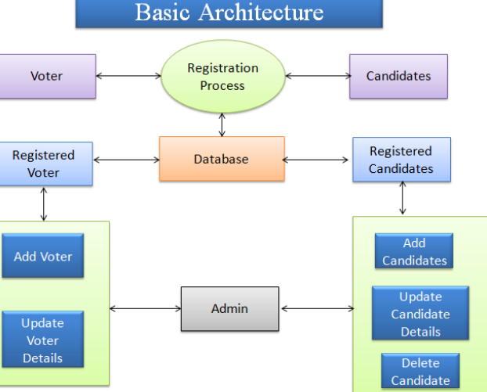

Fig No. 4.1 Work flow diagram

### CHAPTER-5

**RESULT**

### RESULT

**LOGIN PAGE**

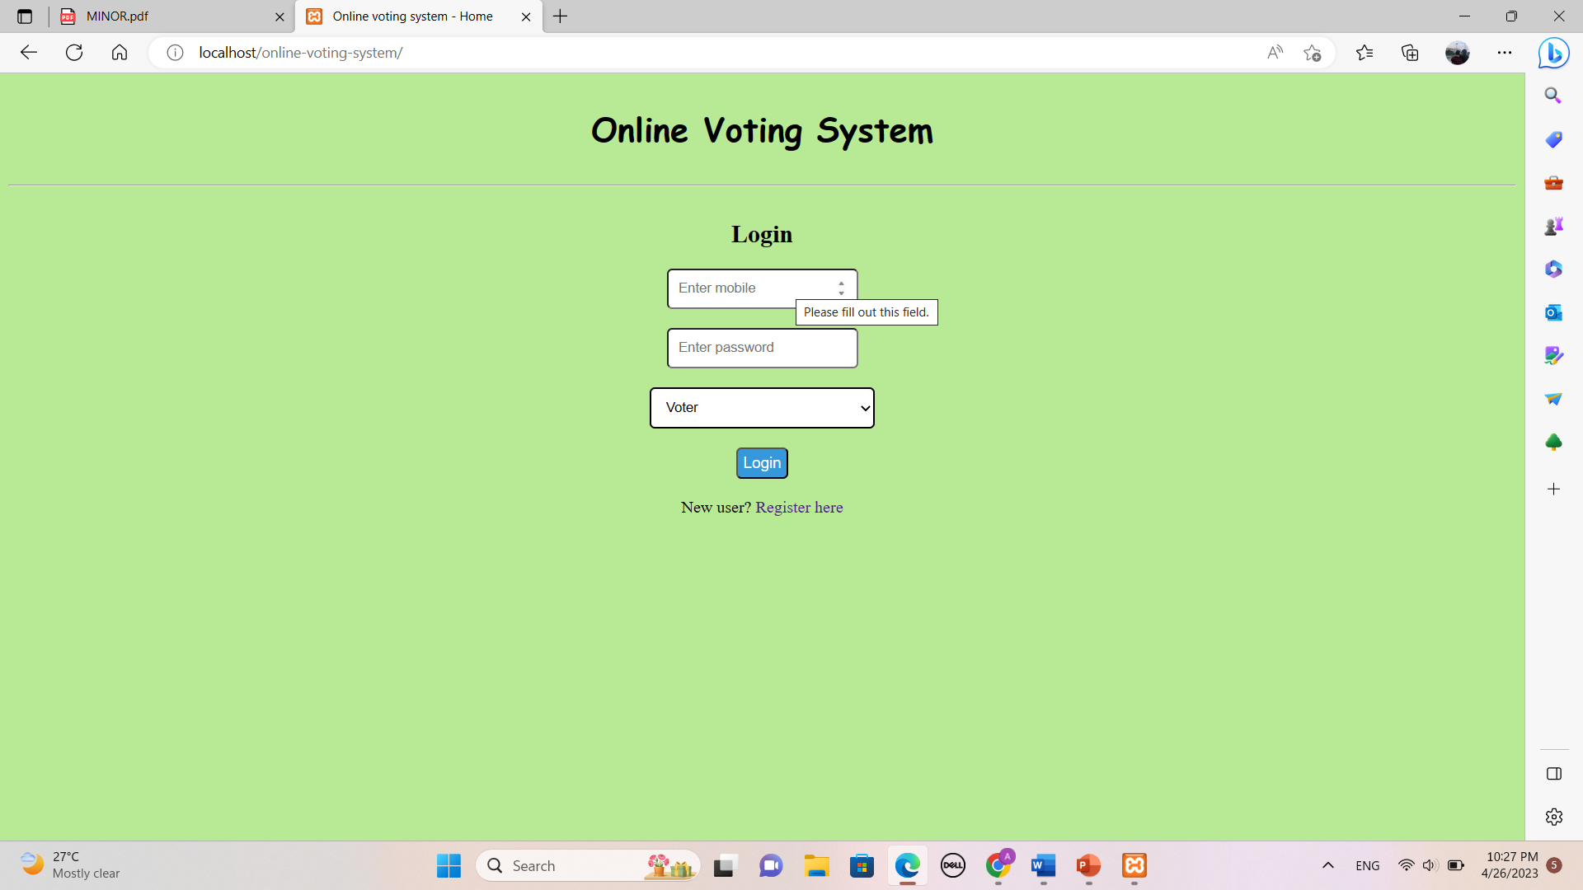

Figure No :5.1 LOGIN PAGE

**REGISTRATION PAGE**



Figure No 5.2 REGISTRATION PAGE

### ADMIN LOGIN PAGE



Figure No 5.3 ADMIN LOGIN PAGE

**VOTING PAGE**

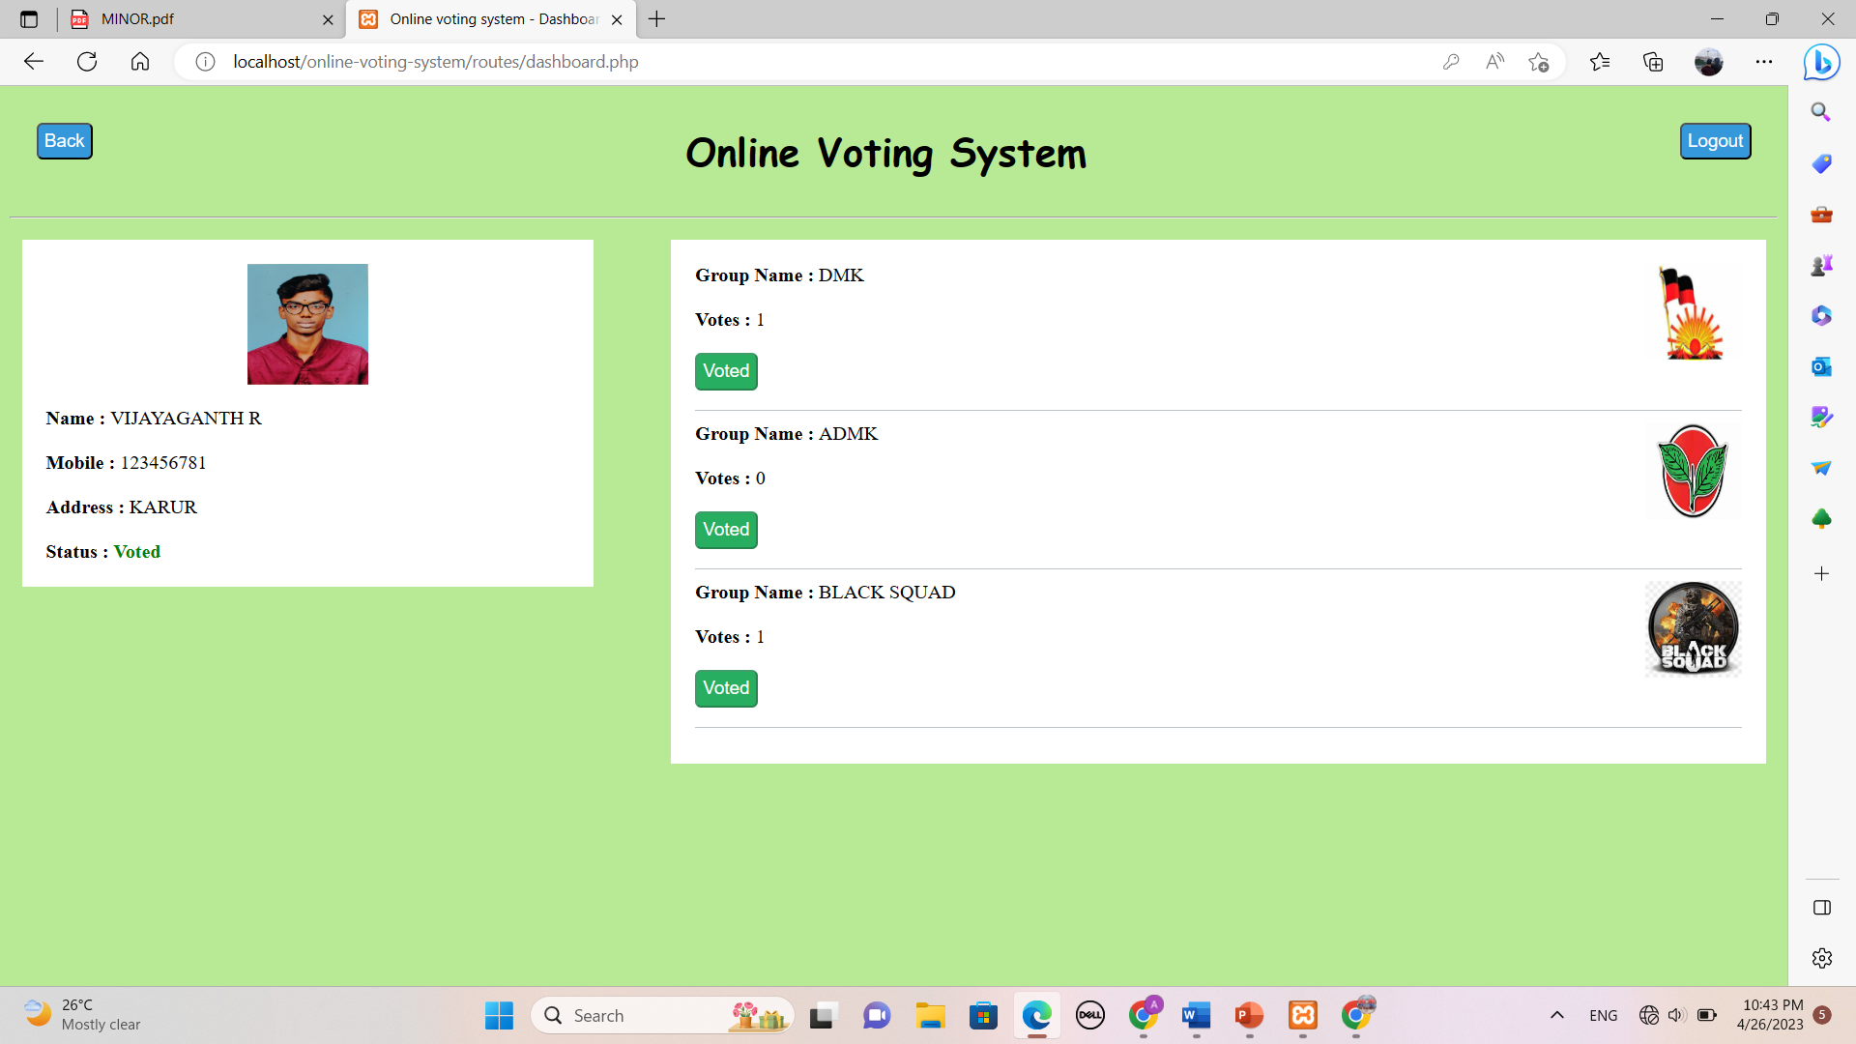

Figure No 5.4 VOTING PAGE

### CHAPTER-6

**CONCLUSION**

### CONCLUSION

This system enables to post their E-Voting details through this website. In this situation Allocate Election Candidate and election data from this vast population is uneasy and difficult one.Time taken is large to existing systemLagging facility in search of election records . Vote report details will be stored in database. When public enter this system and view searching option.Online Voting Systems have many advantages over the traditional voting systemSome of these advantages are less cost, faster generation results, easy accessibility, accuracy, and low risk of human and mechanical errors.It is very difficult to develop online voting system which can allow security and privacy on the high level.

### CHAPTER-7

**REFERENCE**

### REFERENCE

* A Secure and Verifiable Online Voting System .Authors: M. Fujioka, T. Okamoto, and K. Oht Publisher: IEEE Transactions on Information Theory
* A Simple and Secure Online Voting System.Authors: D. Chaum and B. Rivest Publisher: Communications of the ACM
* A Practical and Secure Online Voting SystemAuthors: A. Rivest, B. Schneier, and M. Thompson Publisher: IEEE Security & Privacy Magazine
* A Blockchain-Based Online Voting System Authors: N. Christidis and M. DevetsikiotisPublisher: IEEE Access
* A Simple Online Voting System for Students Authors: J. Smith and J. Doe Publisher: Journal of Information Systems Education